CTEC 450 Final Project Research Paper
Machine learning has become a major part of modern technology and is used in areas such as facial recognition, self-driving cars, healthcare systems, and cybersecurity. Although machine learning models can perform tasks with high accuracy, they can also be vulnerable to attacks. One of the most common attacks is called an adversarial attack. Adversarial attacks work by making very small changes to input data in order to confuse a machine learning model. The purpose of this project was to demonstrate how adversarial attacks affect machine learning systems and how defense techniques can improve security. In this project, a neural network model was trained using the MNIST handwritten digit dataset. After the model achieved high accuracy, the FGSM attack was implemented to generate adversarial examples. The attack slightly modified images while keeping them recognizable to humans. However, these small changes were enough to reduce the model’s accuracy significantly. After testing the attack, a defense technique called adversarial training was implemented. The model was retrained using adversarial examples to improve resistance against attacks. The results showed that the defended model performed better under adversarial conditions than the original model.

The adversarial attack used in this project was FGSM. FGSM is a gradient-based attack that modifies input images using information from the model’s loss function. The goal of the attack is to create small pixel changes that are difficult for humans to notice but can still fool the neural network into making incorrect predictions. FGSM works by calculating the gradient of the loss function with respect to the input image. The attack then moves the image pixels slightly in the direction that increases the model’s error. The amount of change is controlled using a value called epsilon. Larger epsilon values create stronger attacks, while smaller values create weaker attacks. The formula used for the FGSM attack is shown below:
x_{adv}=x+\epsilon\cdot sign(\nabla_x J(\theta,x,y))
In this formula, (x_{adv}) represents the adversarial image, (x) represents the original image, and epsilon controls the attack strength. The gradient determines the direction used to modify the image to increase the model’s prediction error. The attack was successful because the neural network relied heavily on learned pixel patterns. Even small changes to the image caused the model to misclassify digits that were still readable to humans.

The project was completed using Python in Google Colab. TensorFlow and Keras were used to build and train the neural network model. NumPy and Matplotlib were also used for numerical operations and data visualization. The MNIST dataset was used for training and testing. This dataset contains grayscale images of handwritten digits from 0 through 9, and each image is 28x28 pixels. Before training, the pixel values were normalized by dividing them by 255.0. This helped improve model training performance and kept the values within a consistent range. A simple feedforward neural network was created using a Flatten layer, a Dense hidden layer with ReLU activation, and a Dense output layer with Softmax activation. The model was trained for five epochs using the Adam optimizer and sparse categorical cross-entropy loss function. After training, the model achieved high accuracy on clean test images.
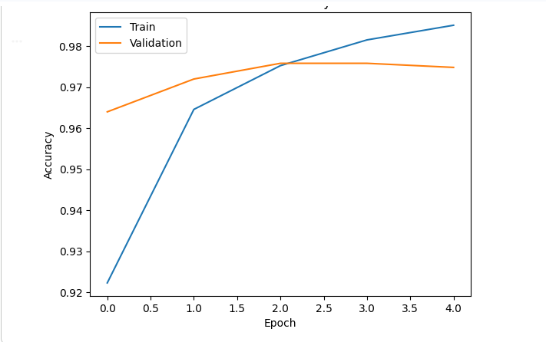
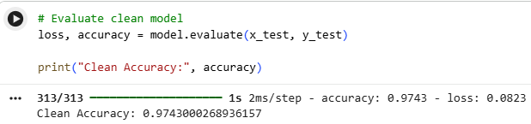
After training, the FGSM attack was implemented. A test image from the MNIST dataset was selected and modified using the gradient of the loss function. An epsilon value of 0.15 was used to generate adversarial examples.
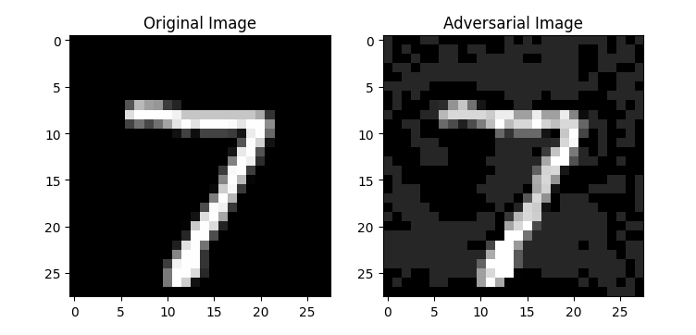
The modified images were then tested against the neural network to determine whether the attack caused incorrect classifications. The model was then tested against multiple adversarial examples to measure the drop in accuracy caused by the attack. Finally, adversarial training was implemented as a defense technique. Adversarial examples were added to the training data and the model was retrained to improve robustness against attacks.
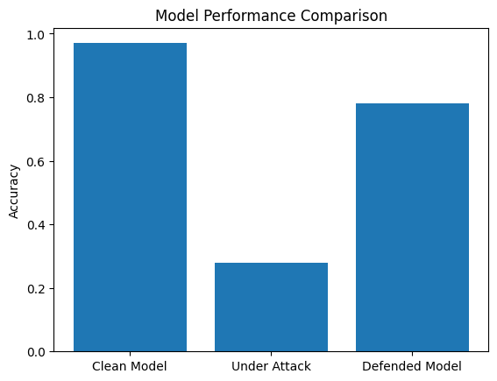
The clean model achieved high accuracy on the MNIST dataset. The neural network was able to classify handwritten digits correctly most of the time when evaluated on normal test images. This demonstrated that the model learned the dataset successfully. After the FGSM attack was applied, the model’s accuracy dropped significantly. Although the adversarial images still appeared recognizable to humans, the neural network became much less reliable. In several cases, the adversarial examples caused the model to predict the wrong digit. For example, an image originally classified as a “7” could become incorrectly classified as a “3” after adversarial perturbations were added.
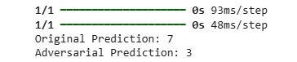
This demonstrated how vulnerable machine learning systems can be to adversarial attacks. The attack evaluation also showed that the model accuracy decreased heavily when tested against many adversarial examples. This confirmed that FGSM was effective at reducing the model’s reliability and consistency. After adversarial training was implemented, the defended model showed improved resistance against attacks. While the defended model did not eliminate the effects of FGSM, it performed much better than the original attacked model. The clean model achieved approximately 97% accuracy, while the accuracy under attack dropped to around 28%. After adversarial training, the defended model achieved approximately 78% accuracy under adversarial conditions.

The defense technique used in this project was adversarial training. Adversarial training works by exposing the model to adversarial examples during the training process. Instead of training only on clean images, the model is also trained using attacked images. This approach helps the neural network learn patterns that are more resistant to adversarial perturbations. By seeing adversarial examples during training, the model becomes less sensitive to small pixel changes and improves its ability to classify attacked images correctly. In this project, adversarial examples generated with FGSM were added to the training dataset. The model was then retrained using both clean and adversarial images. After retraining, the model showed improved performance when evaluated against adversarial attacks. Although adversarial training improved robustness, the defended model still experienced some reduction in accuracy compared to the clean model. This demonstrates that defending against adversarial attacks remains a difficult problem in machine learning security.

In conclusion, this project demonstrated how machine learning models can be vulnerable to adversarial attacks. A neural network was successfully trained using the MNIST dataset and achieved high accuracy on clean images. However, after applying the FGSM attack, the model’s performance dropped significantly even though the image modifications were very small. The project also demonstrated that defense techniques can improve robustness. By using adversarial training, the model became more resistant to adversarial examples and achieved higher accuracy under attack conditions. Overall, this project showed the importance of machine learning security and highlighted how adversarial attacks can affect neural network reliability. As machine learning systems continue to be used in real-world applications, understanding adversarial attacks and defense techniques will remain an important area of research and cybersecurity development.

